**Data Structures and Algorithms**

**Lab Report**

**Lab06**



|  |  |
| --- | --- |
| Group Members Name & Reg #: | **Muhammad Haris Irfan**  **(FA18-BCE-090)** |
|  |  |
| Class | Data Structures and Algorithms CSC211 (**BCE-3B**) |
| Instructor’s Name | Dilshad Sabir |

**Pre-Lab Task**

**Task:1**

**Complete the functions ‘enqueue ()’, ‘dequeue ()’ and peek () functions.**

**Solution:**

The code is shown below,

Dequeue Code:

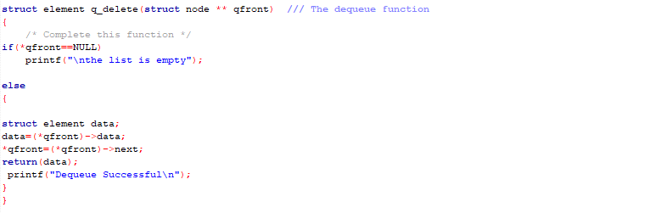

Enqueue Code:

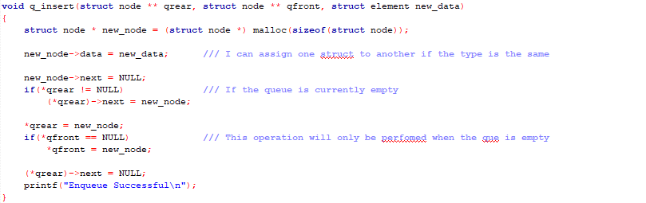

Peek Code:

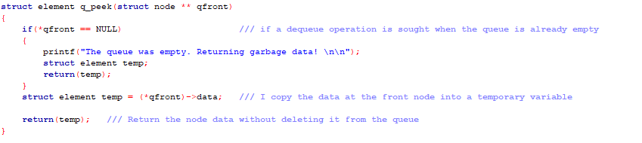

The Result of the following code is attached below:

Enqueing:

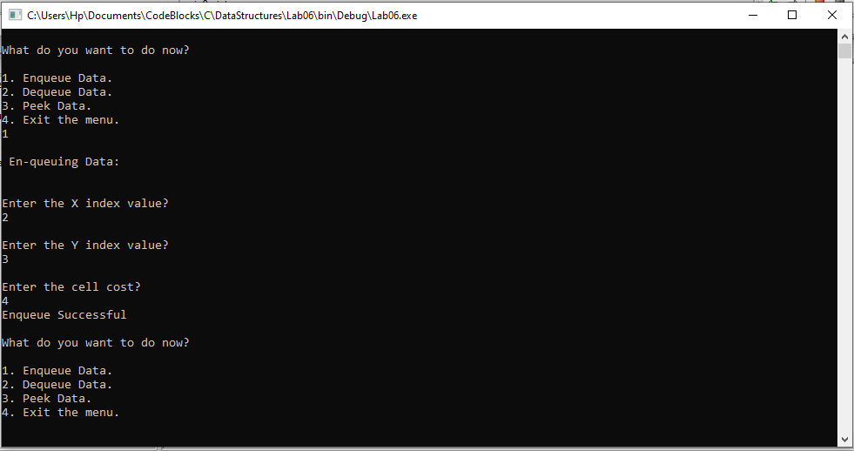

Peeking:

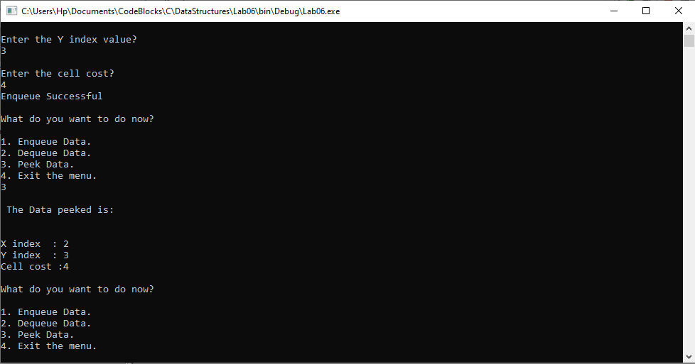

Dequeing:

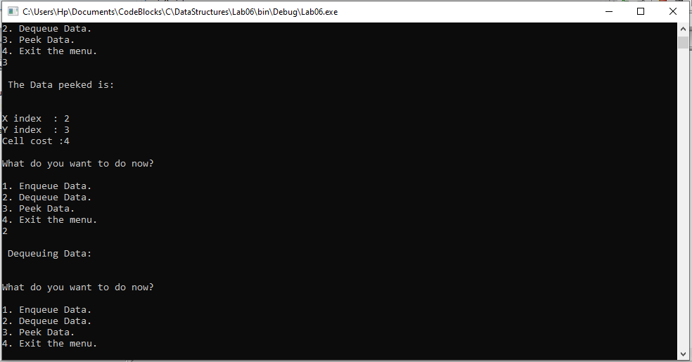

-------------------------------

**In Lab Tasks**

**Task:1**

**Implement a priority queue. (Enqueue Function).**

**Solution:**

The code is shown below,

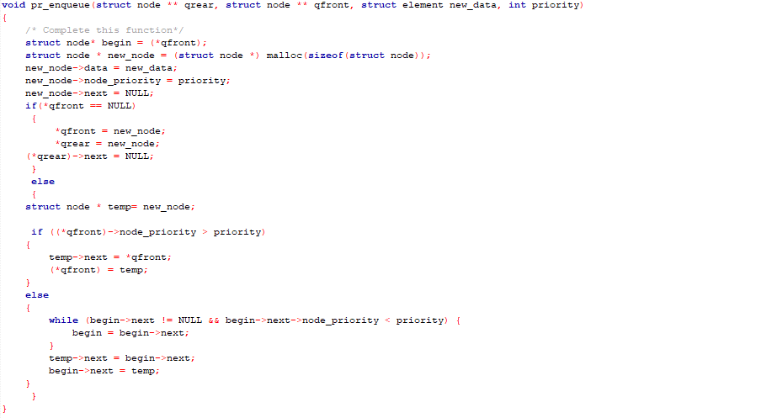

The Result of the following code is attached below:

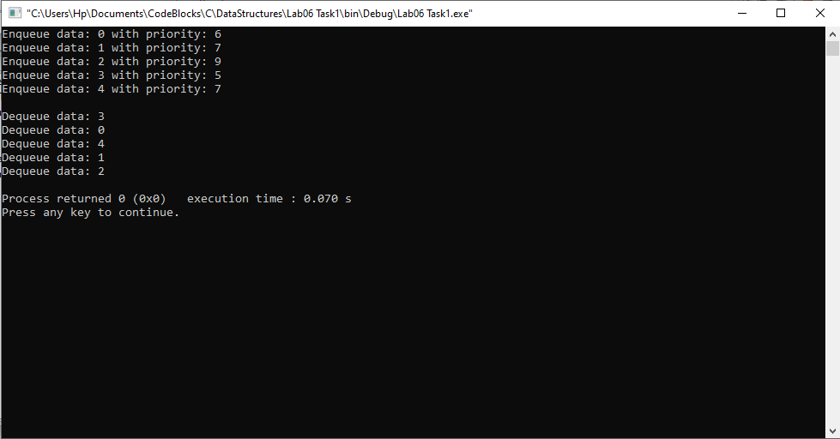

-------------------------------

**Task:2**

**Find the Shortest Path in Graphs Using BFS and Queues. (Avoiding 1s)**

Solution

The code is shown below,

Only this condition was enough to avoid the ones and find the shortest path.

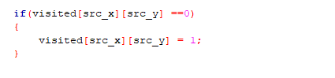

The Result of the following code is attached below:

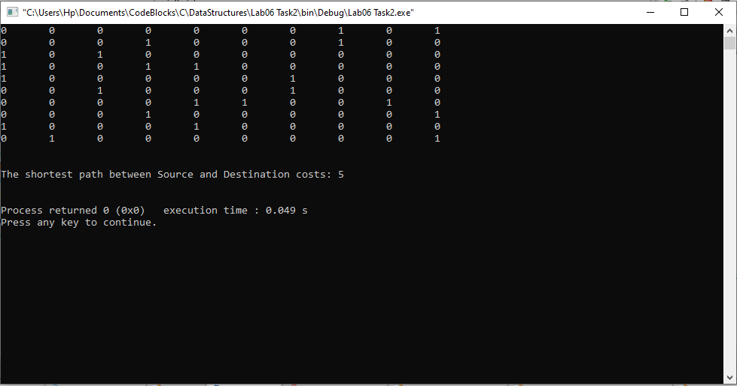

------------------------------

THE END